LAB Assignment No 7
Recurrent Neural Network (RNN)
LAB Task 1:
Next Word Prediction using RNN
Objective: Learn how RNNs can predict the next word in a sentence.
Dataset: Any small text corpus — e.g., Shakespeare.txt or Wikipedia sample.
Tasks:
- Load and clean the text data.
- Tokenize and convert text into sequences.
- Build a simple RNN model using keras.layers.SimpleRNN.
- Train it to predict the next word given previous 3–5 words.
- Test by entering a custom text prompt and predict the next word.
Output:
Model predicts probable next word, e.g.,
Input: “The sun is” → Output: “shining”
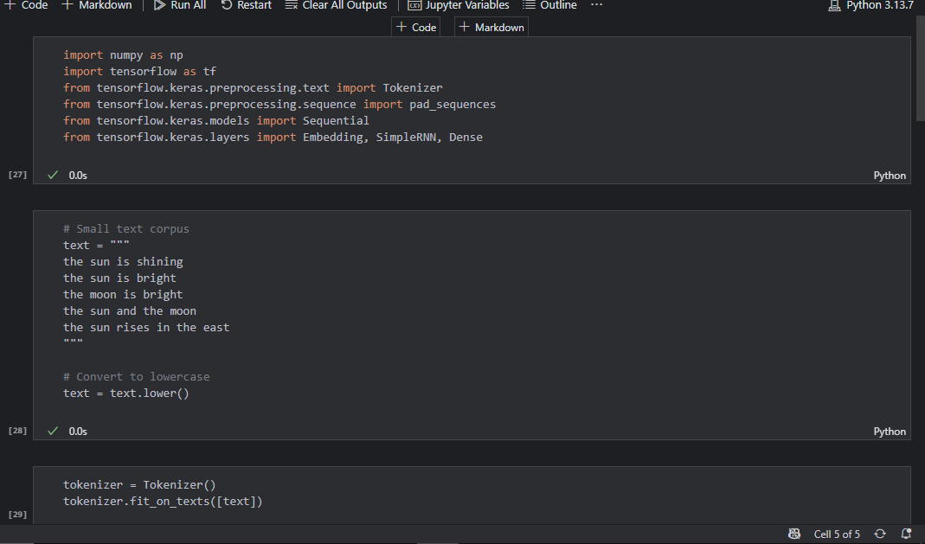
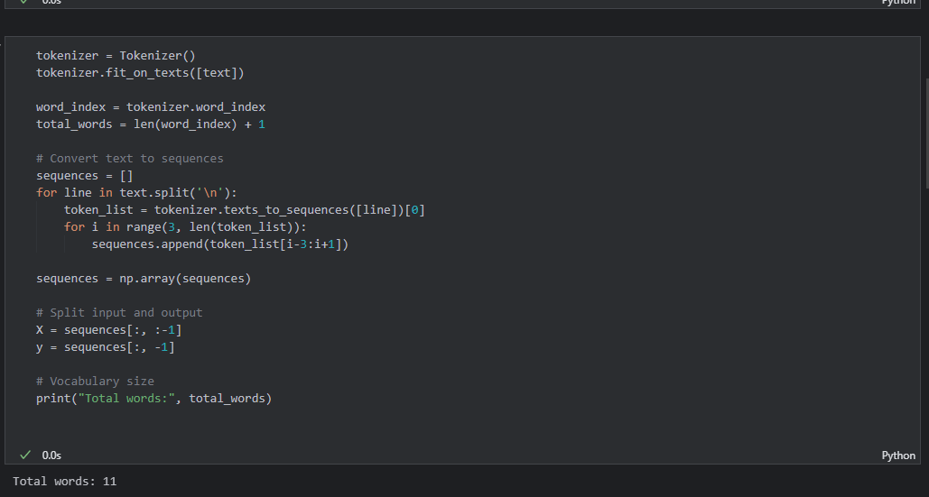
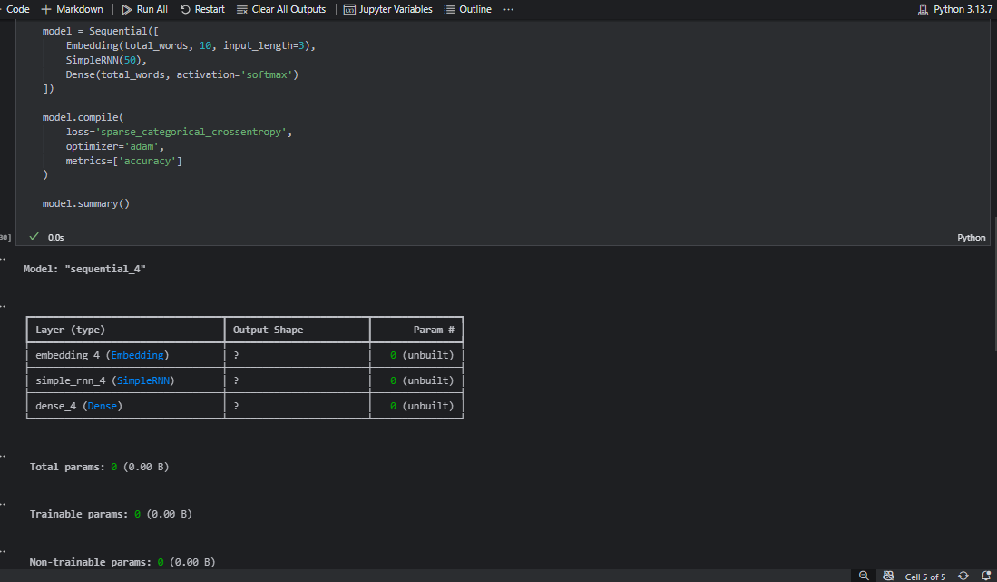
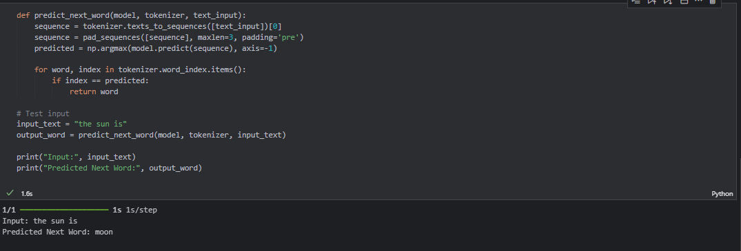

LAB Task 2:
Stock Price Prediction using RNN
Objective: Predict future stock prices using time series data.
Dataset: Use Google Stock Price dataset (from Kaggle or Yahoo Finance).
Tasks:
- Import dataset and normalize values.
- Prepare time-step sequences (e.g., 60 previous days → next day price).
- Build and train an RNN model using SimpleRNN layers.
- Evaluate predictions vs actual prices (plot graph).
Output:
Line graph showing predicted vs real stock price trend.
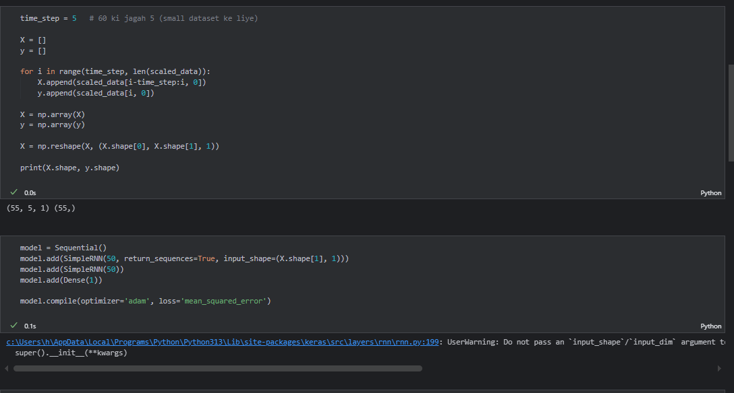
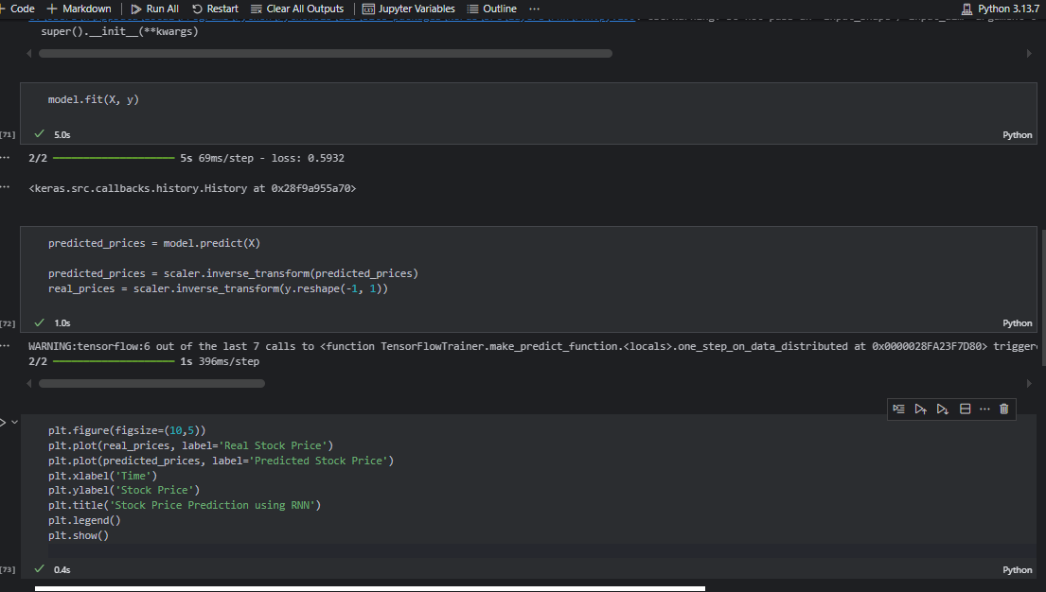
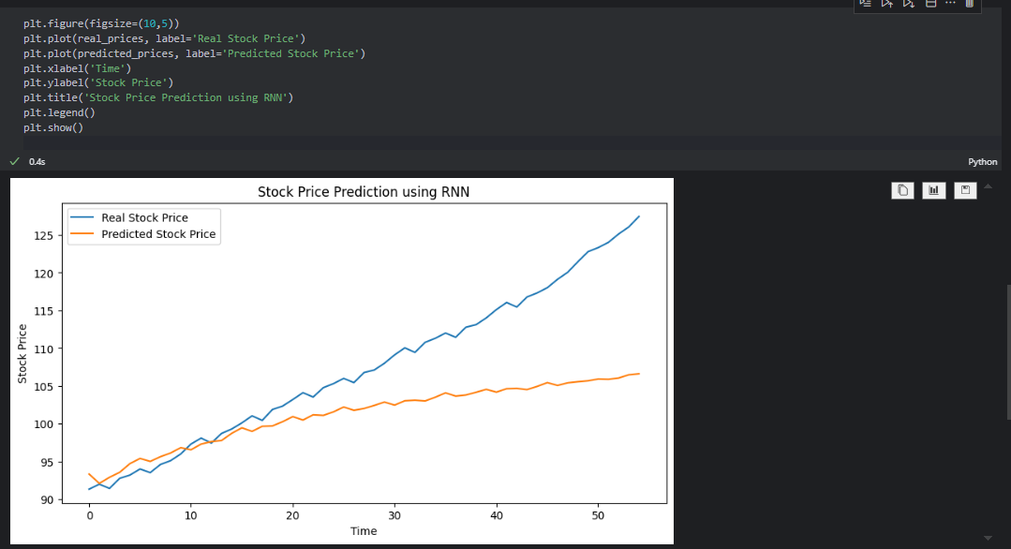
LAB Task 3:
Sentiment Analysis using RNN
Objective: Classify movie reviews as positive or negative using RNN.
Dataset: IMDb Movie Reviews dataset (available in Keras).
Tasks:
- Load dataset and preprocess text (tokenize and pad sequences).
- Build RNN with Embedding + SimpleRNN layers.
- Train for binary classification (positive/negative).
- Evaluate accuracy on test data.
Output:
Accuracy score (e.g., 85%) and prediction for custom input text.
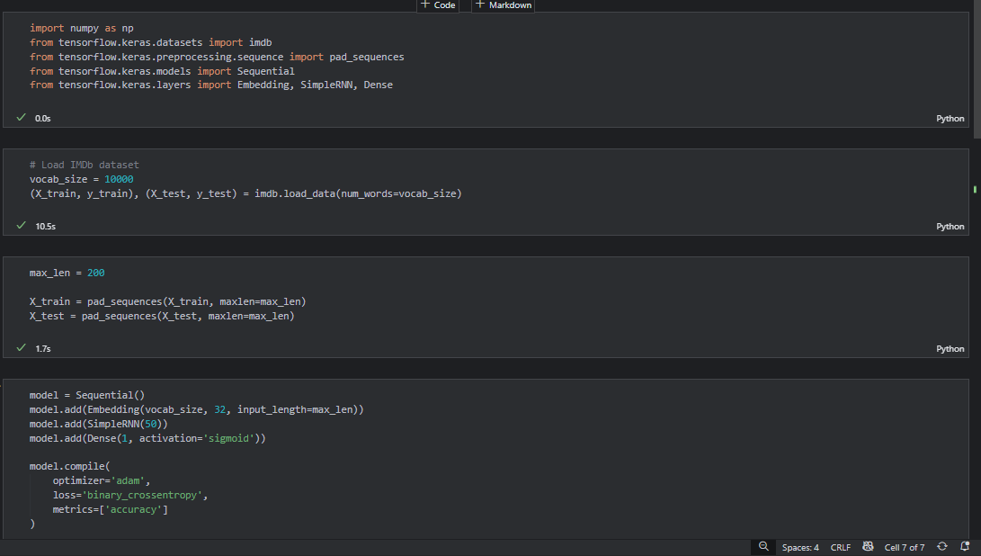
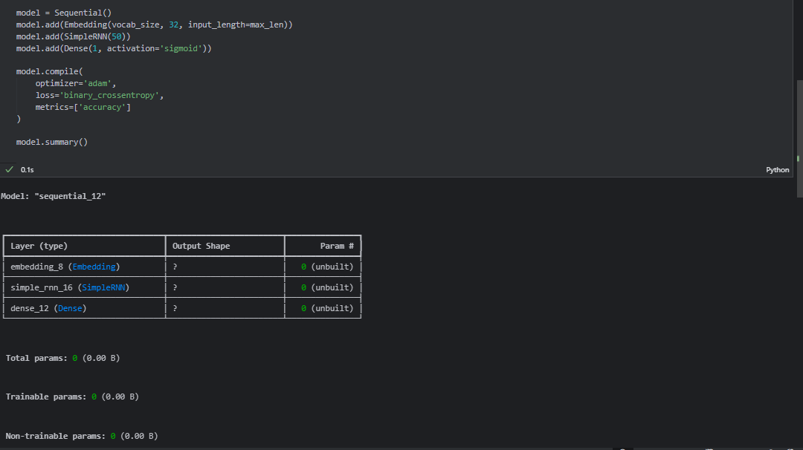
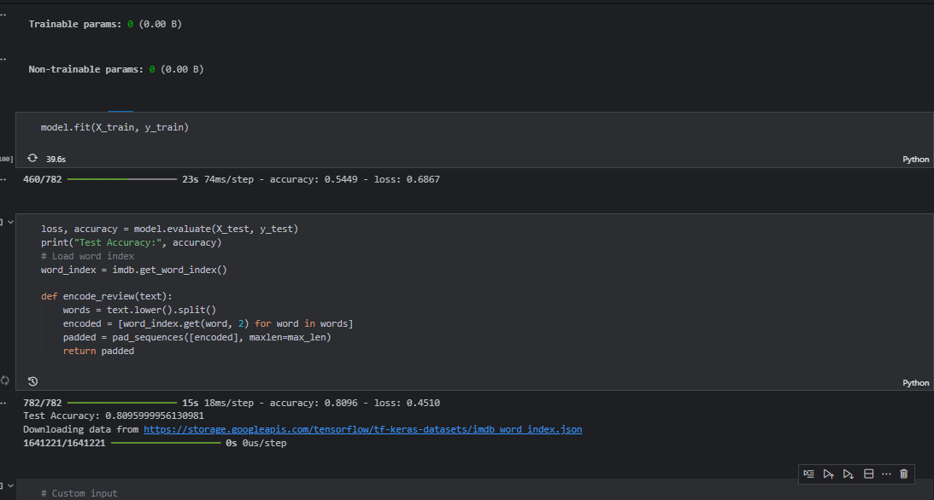
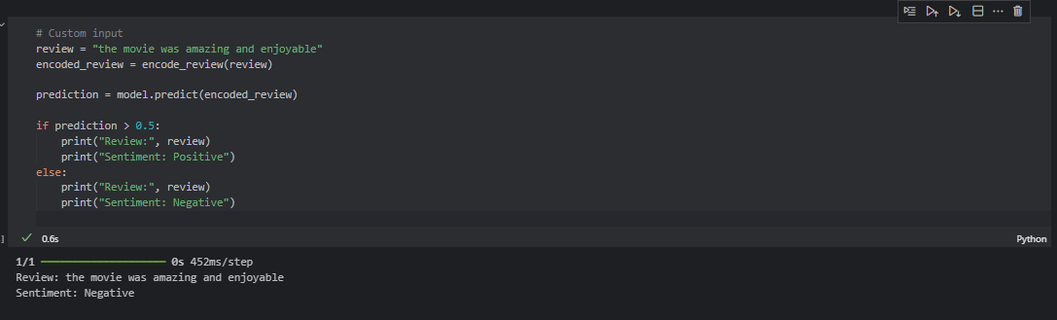

LAB Task 4:
Weather Forecasting using RNN
Objective: Predict future temperature based on previous days’ readings.
Dataset: Daily temperature dataset (e.g., “Jena Climate Dataset” from TensorFlow).
Tasks:
- Load and visualize temperature over time.
- Prepare input-output sequences for time series prediction.
- Build an RNN to predict next day’s temperature.
- Plot actual vs predicted temperature.
Output:
Graph showing predicted vs actual temperature trends.
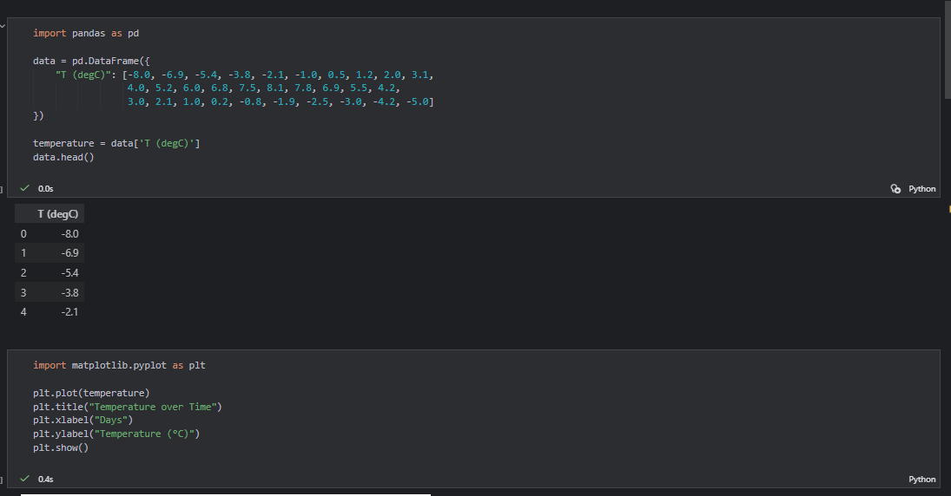
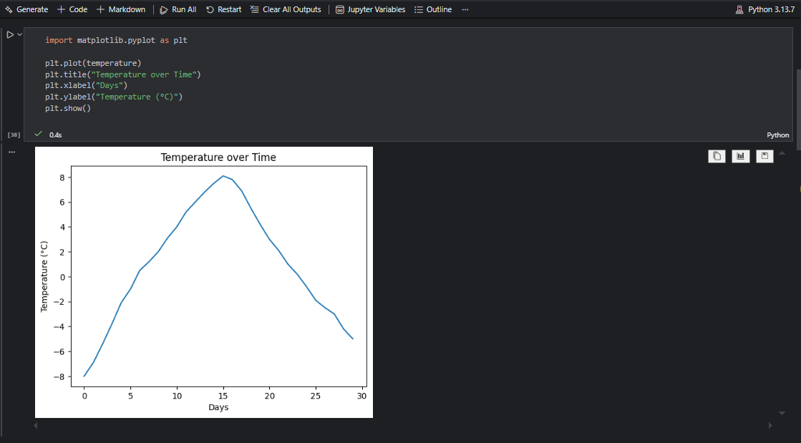
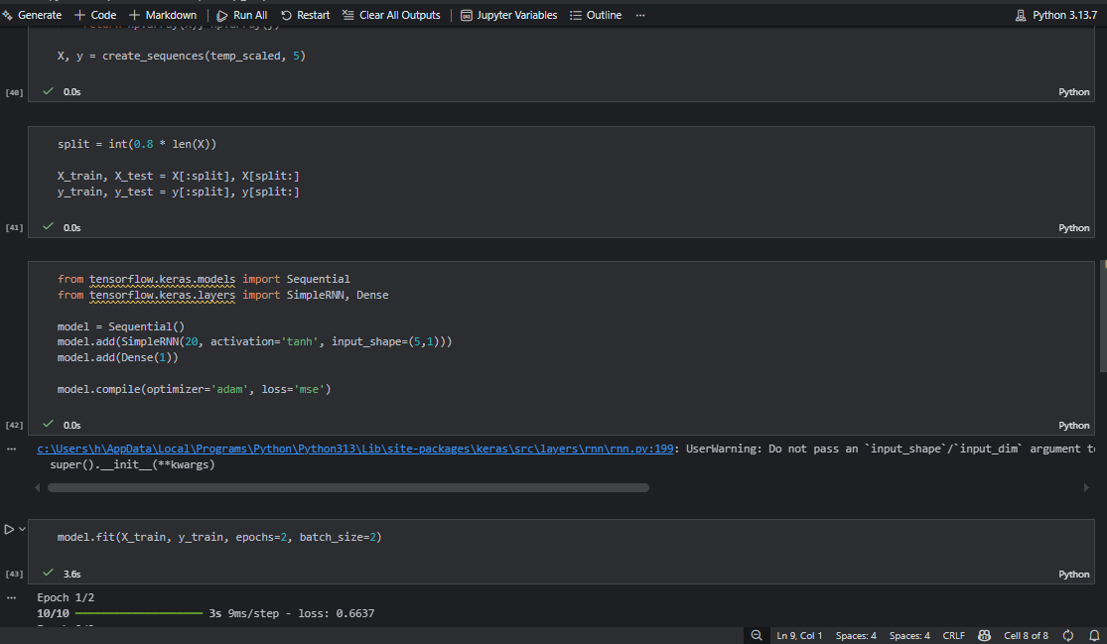
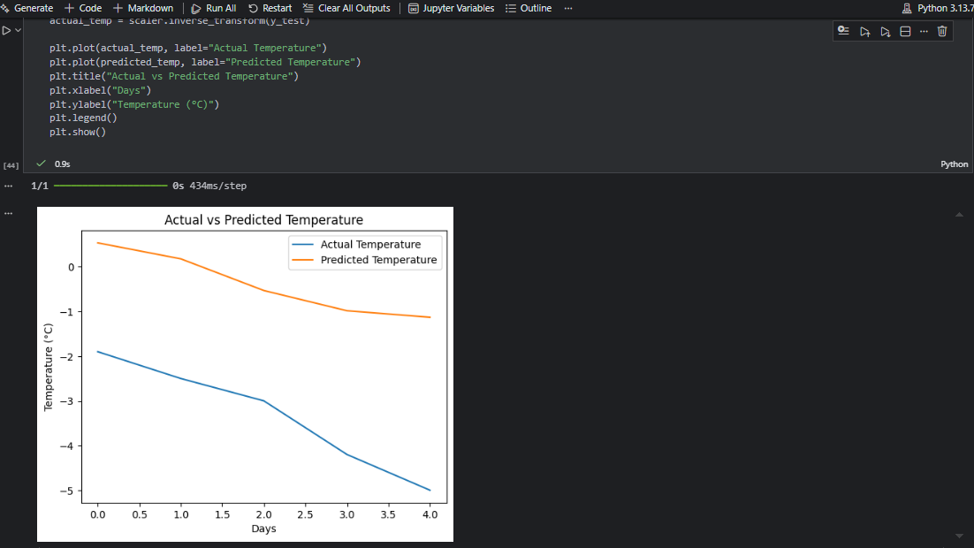

LAB Task 5:
Music Note Generation using RNN
Objective: Generate new music sequences using RNN.
Dataset: MIDI music dataset (short sequences or melodies).
Tasks:
- Convert MIDI data into integer-encoded notes.
- Train an RNN on note sequences (input: previous notes → output: next note).
- Generate a new sequence using the trained model.
Output:
A sequence of generated notes that can be converted to a playable MIDI file
